# A day in the life of a District Rural Officer

On Tuesday 30th January, Matt Jeffrey (Arthur Rank Centre CEO) and I were privileged to spend the day with Rev Richard Wilde, Rural Officer for Birmingham Methodist District.

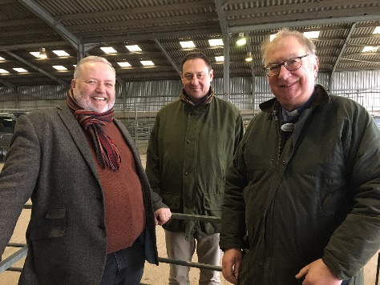First stop - Stratford Livestock market, where the consistent presence and prayerful listening of a rural chaplain is welcomed and appreciated both by those who gather and those who work there. We were able to speak with the senior auctioneer Alastair Brown (who is also Chair of the National Livestock Auctioneers Association) about the multiple challenges faced by local farmers, as well as the national & international pressures upon those working in the agricultural sector. This week’s sale consisted of mostly sheep… and two goats! [photo L-R; Matt Jeffrey ARC, Alastair Brown, Rev Richard Wilde]

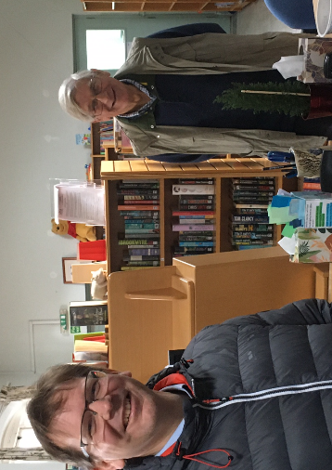Next stop - lunch break at [Henley-in-Arden chapel](https://www.methodist-swc.org.uk/local-churches/minister-audrey-simpson/henley-in-arden.html), where we met two members keen to show us around. Andrew Steele and his father, Local Preacher James Steele (pictured below in the community library). Their family have been members since the chapel was built in 1894. Henley in Arden is now a class of Stratford upon Avon Methodist Church.

The chapel entrance hosts the community fridge – open for both donations and for taking what you need. The main worship space is flexible and rented out to various groups during the week. The former school room behind the worship space now hosts a community library. The chapel has already attained an A Rocha Eco church silver award. As Richard says; “It was inspiring to hear just what is possible in a rural location with some creativity and partnership working. This has enabled there to be a continuing & meaningful Methodist presence in a small community when membership has dropped below twelve.”

Our final stop for the day – we attended the launch of the [Hidden Hardship exhibition](https://hiddenhardship.coventry.ac.uk/index.php/2024/01/31/hidden-hardship-exhibition-arrives-in-coventry-cathedral/) at Coventry Cathedral.

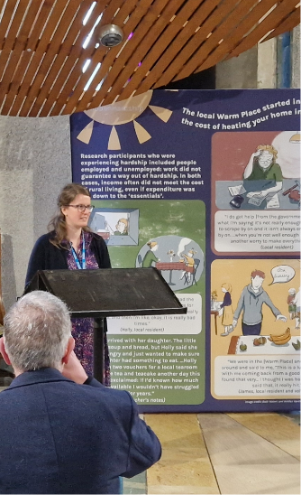Dr Stephanie Denning’s research findings around coping strategies and barriers to wellbeing in rural Britain is presented in an accessible format alongside some beautiful artwork by Beth Waters. The recommendations are all things we can/should be raising awareness about, as well as bringing to the attention of our local and national government leaders.

An online visual booklet of the exhibition can be found here: [Hidden Hardship Short Storybook - Hidden Hardship (coventry.ac.uk)](https://hiddenhardship.coventry.ac.uk/index.php/hidden-hardship-short-storybook/)

For details of rural mission support offered across Britain, please see [Rural Hope (methodist.org.uk)](https://www.methodist.org.uk/our-work/our-work-in-britain/evangelism-growth/rural-hope/)

or contact Sarah Hulme, Methodist rural mission & ministry officer.