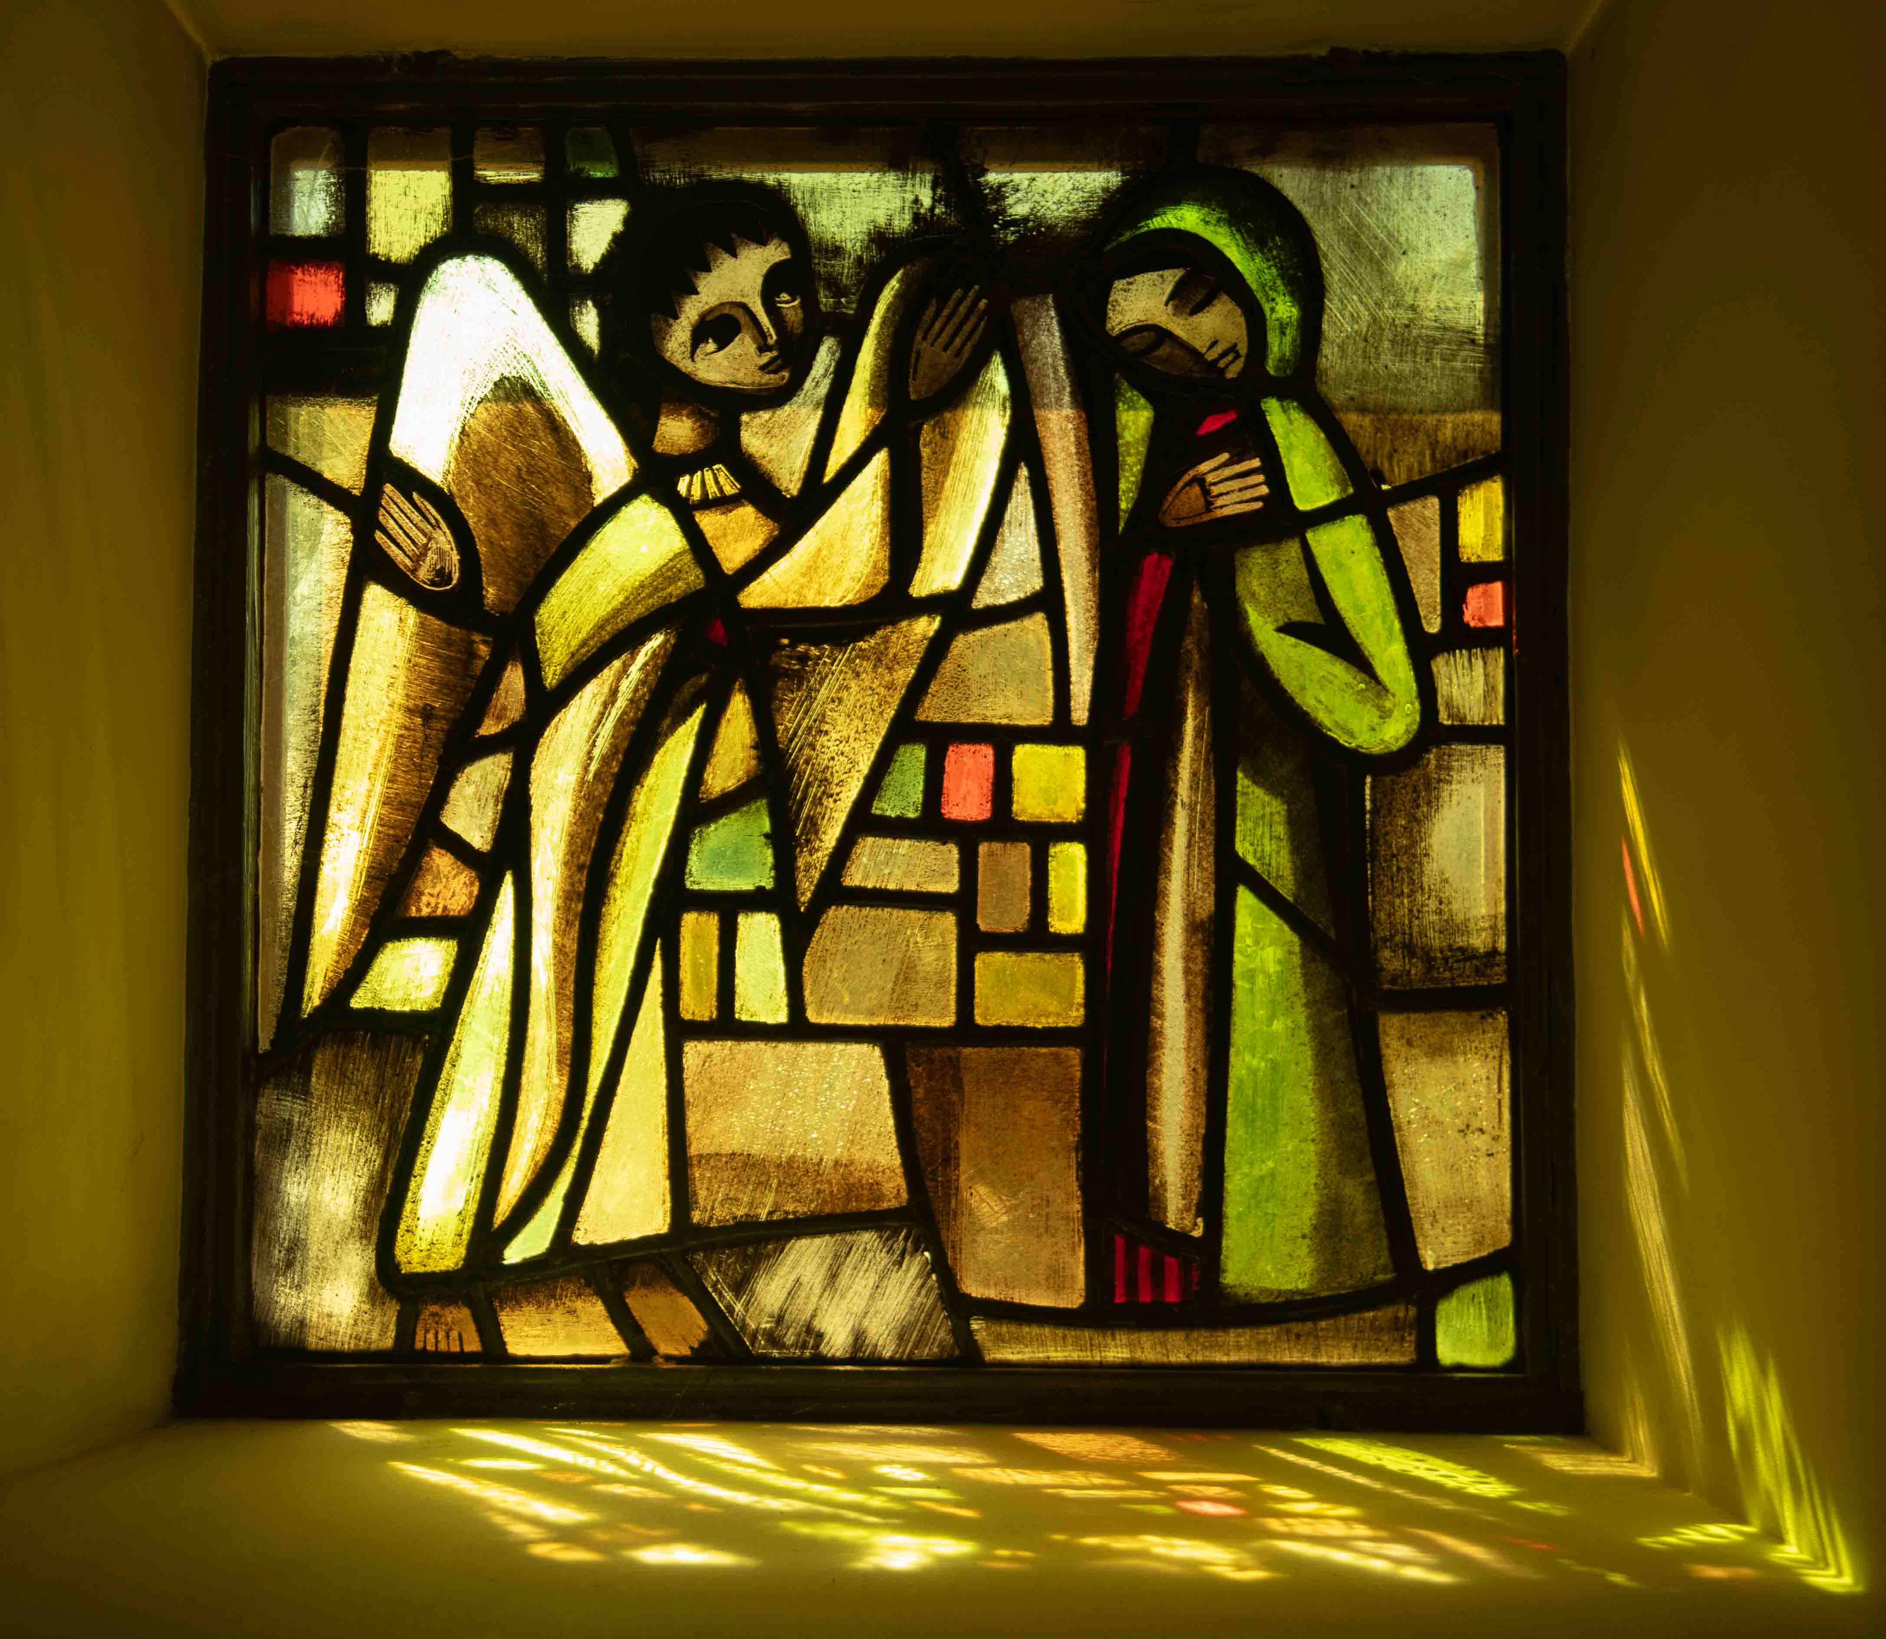
Prayer in the way of
Taize

6pm Sunday 19th November
St Francis, Sycamore Rd, Bournville, B30 2AA

6pm Sunday 17th December
The Church at Carrs Lane,
Carrs Lane, Birmingham B4 7SX

5pm Saturday 20th January 2024
St Philip’s Cathedral, Colmore Row
Birmingham B3 2QB

All Welcome
For more information contact
phpaw2@btinternet.com 0121 478 3841

